**DAILY ONLINE ACTIVITIES SUMMARY**

|  |  |  |  |  |  |  |  |  |
| --- | --- | --- | --- | --- | --- | --- | --- | --- |
| **Date:** | **29/06/2020** | | | | | **Name:** | **NAIPUNYA VINOD NAIK** | |
| **Sem & Sec** | **IV SEM & A SECTION** | | | | | **USN:** | **4AL18CS050** | |
| **Online Test Summary** | | | | | | | | |
| **Subject** | | **NO INTERNALS CONDUCTED** | | | | | | |
| **Max. Marks** | | **------------------** | | **Score** | | | **-------------------** | |
| **Certification Course Summary** | | | | | | | | |
| **Course** | **1)** INTRODUCTION TO AI,MACHINE LEARNING AND DATA SCIENCE 2020  **2)** ANDROID ETHICAL HACKING COURSE  **3)** ARTIFICIAL NEURAL NETWORKS[THEORY & HANDS-ON]  **4) WEBINAR ON CYBER SECURITY &APPLICATIONS** | | | | | | | |
| **Certificate Provider** | | | **1) UDEMY**  **2) UDEMY**  **3) UDEMY**  **4) AIET** | | | **Duration** | | **1) 32 MIN**  **2) 34 MIN**  **3) 2 HRS**  **4) 2 HRS** |
| **Coding Challenges** | | | | | | | | |
| **Problem Statement: 1)** [Given a list of numbers, write a Python program to count Even and Odd numbers in a List.](https://github.com/orgs/alvas-education-foundation/teams/2nd-year/discussions/139) | | | | | | | | |
| **Status: EXECUTED** | | | | | | | | |
| **Uploaded the report in Github** | | | | | **YES** | | | |
| **If yes Repository name** | | | | | <https://github.com/naipunya-naik/lockdown-coding/blob/master/PYTHON%20CODING/Even%20Odd%20Count_29-06-2020.py> | | | |
| **Uploaded the report in slack** | | | | | **YES** | | | |

Online Test Details: (Attach the snapshot and briefly write the report for the same)

NO INTERNALS CONDUCTED

Certification Course Details: (Attach the snapshot and briefly write the report for the same).

1) CERTIFICATION COURSE NAME:- INTRODUCTION TO AI,MACHINE LEARNING AND DATA SCIENCE 2020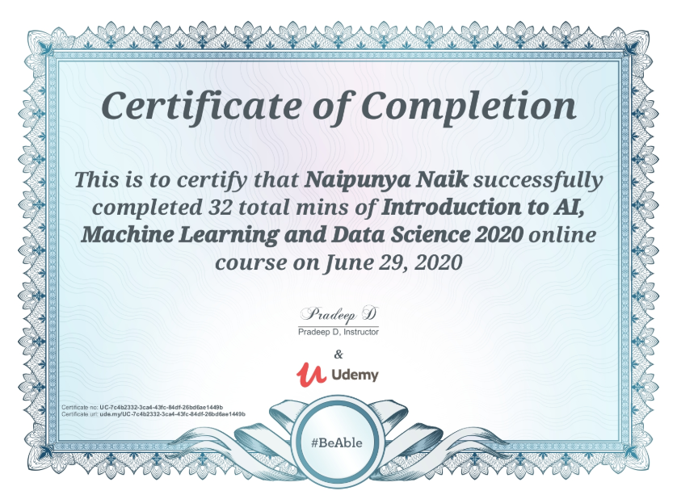

TOPICS LEARNT ON 29 JUNE 2020:-

* **Introduction to buzz words like AI, Machine Learning, Data Science and Deep Learning etc.**
* **Real time examples where Machine Learning can be used to solve real world business problems**
* **Introduction to Supervised Learning and Unsupervised Learning**
* **Introduction to Natural Language Processing**
* **Why python is popular for Machine Learning**

2) CERTIFICATION COURSE NAME:- ANDROID ETHICAL HACKING COURSE



TOPICS LEARNT ON 29 JUNE 2020:-

* Android’s Security Model
* Permissions
* Package Management

3) CERTIFICATION COURSE NAME:- ARTIFICIAL NEURAL NETWORKS[THEORY & HANDS-ON]

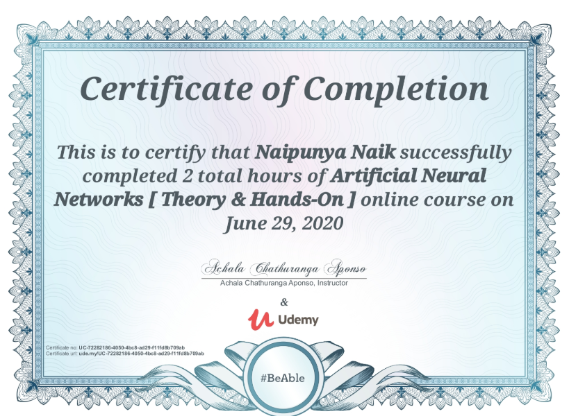

TOPICS LEARNT ON 29 JUNE 2020:-

* Beginners Guide to Artificial Neural Networks - Theory
* Building Artificial Neural Networks with KERAS
* Setting up the Environment for building Artificial Neural Networks
* Python Basics

4) WEBINAR ON CYBER SECURITY & APPLICATIONS

* CONDUCTED BY:- DR MANJUNATH KOTARI,HOD CSE,AIET
* SUBJECT:- CYBER SECURITY AND APPLICATIONS
* FROM 11.00 AM TO 1.00 PM
* DURATION :- 2 HRS
* THE WEBINAR COMPRISED OF TWO QUIZZES ,QUIZ 3 & QUIZ 4
* EACH QUESTION OF CYBER 3 QUIZ & CYBER 4 QUIZ CARRIED 1 MARK

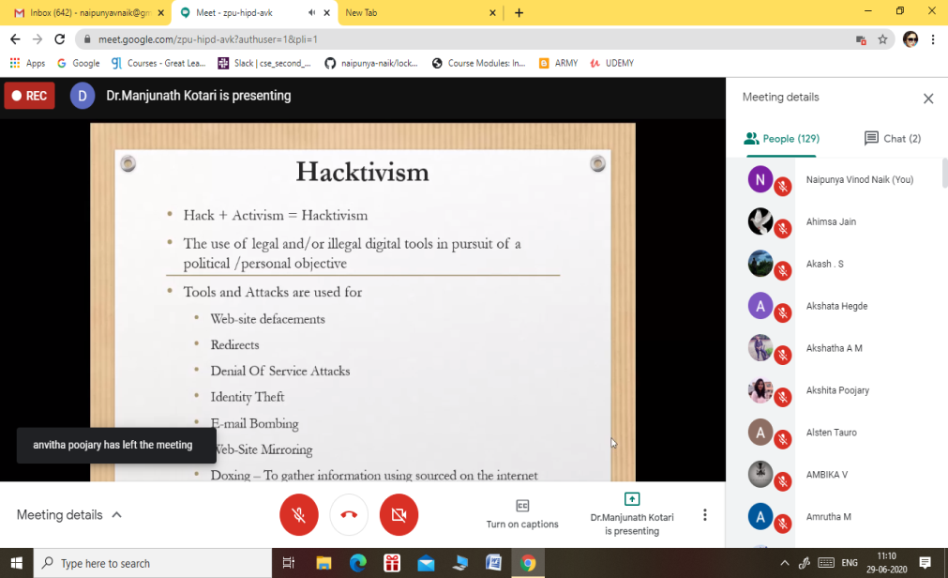

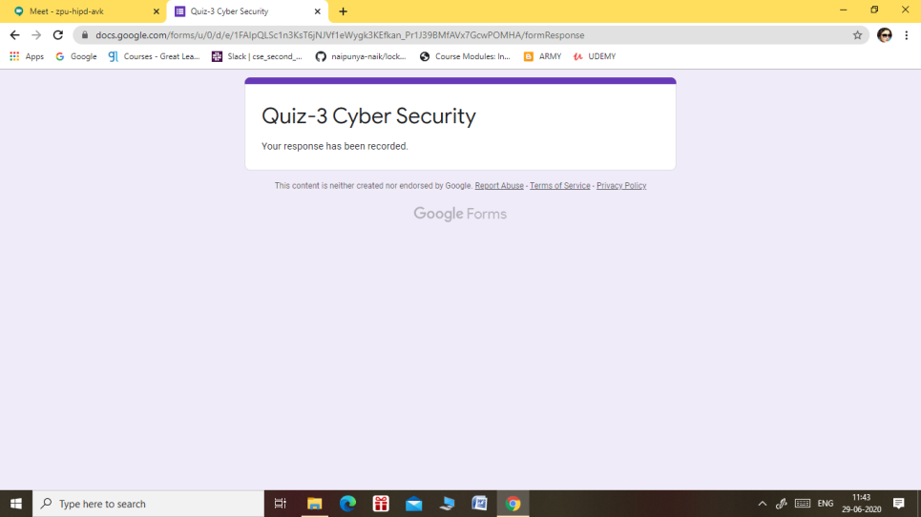

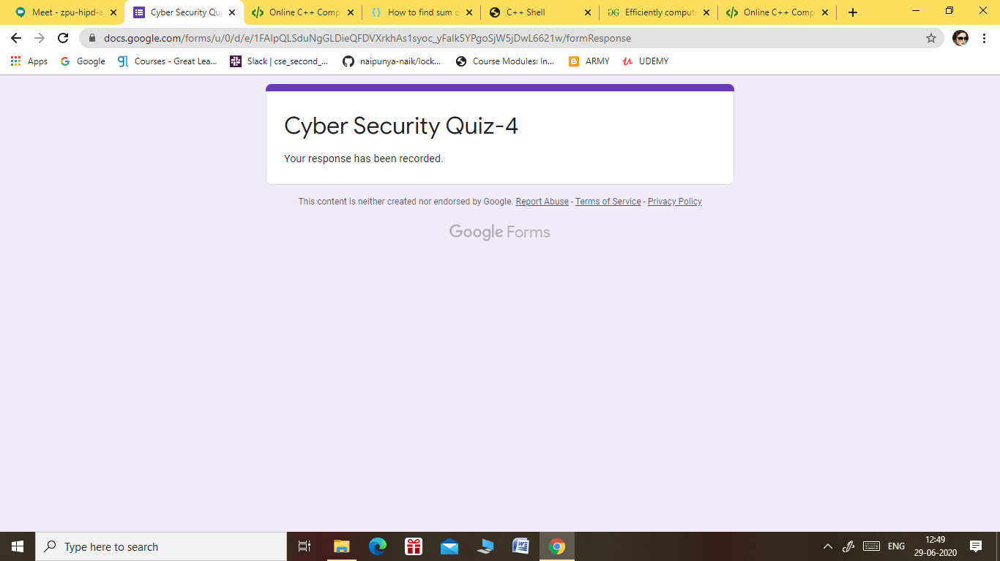

Coding Challenges Details: (Attach the snapshot and briefly write the report for the same)

PROBLEM STATEMENT:- [Given a list of numbers, write a Python program to count Even and Odd numbers in a List.](https://github.com/orgs/alvas-education-foundation/teams/2nd-year/discussions/139)

Top of Form

Bottom of Form

|  |
| --- |
| Example: Input: list1 = [2, 7, 5, 64, 14] Output: Even = 3, odd = 2 Input: list2 = [12, 14, 95, 3] Output: Even = 2, odd = 2 Example 1: count Even and Odd numbers from given list using for loop Iterate each element in the list using for loop and check if num % 2 == 0, the condition to check even numbers. If the condition satisfies, then increase even count else increase odd count.  Screenshot (198).png |

GITHUB REPOSITORY LINK:-

<https://github.com/naipunya-naik/lockdown-coding/blob/master/PYTHON%20CODING/Even%20Odd%20Count_29-06-2020.py>